**Creating a Database**

DVD Collection

1. Create a table with the following fields and identify what data types you will need.

* DVD_ID- AutoNumber
* DVD_Title
* Category (Horror, Comedy, Thriller, Drama, Sci-fi, Rom Coms, Musicals, Action)
* Age_Rating (U, PG, 12, 15, 18)
* Price (£3.99, £6.99, £9.99, £14.99)
* Customer_ID (1,2,3,4,5)

Save your table as tbl_dvd

1. Create a new table and put in the following fields (attributes), identifying the correct data types. Save your table as tbl_Customer

Customer ID – Make this your Primary Key

Customer_Surname

Customer_Forename

Address_1

Address_2

Town/City

Postcode

County

Tel_No

e-mail

1. Set the field lengths on the appropriate fields to appropriate sizes
2. Enter the following records into the table
3. Enter Length checks for all valid fields in all tables
4. Enter Presence checks for each of the following fields

In the customer table

Customer Surname

Customer Forename

Telephone Number

E-mail

In the DVD table

DVD_Title

Add lookup tables

Category

Age_rating

Price

In the customer table add input masks for

Postcode

Tel_No

1. Enter 20 records into the DVD table (use the internet if you are struggling to think of 20). When entering values use the suggested above, you will have to repeat some values.
2. Add the following into the Customer table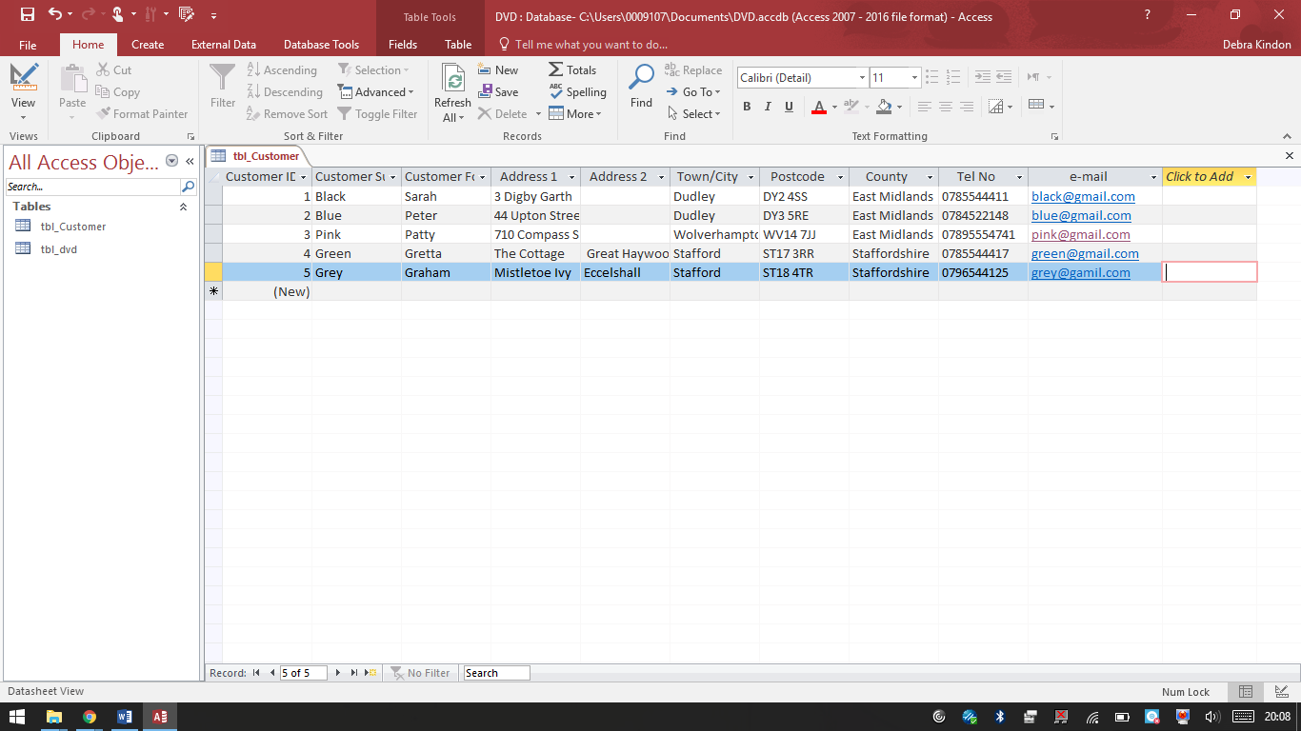
3. Create a query to select all the DVD’s with a rating of 5
4. Create a query to select all DVD’s with prices over £10
5. Create a query to select the category of ‘horror’
6. Experiment and create your own queries
7. Create a form based on your table